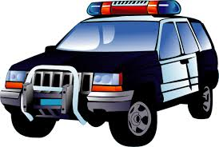
Reporting Criminal Activity

You would be surprised how many people witness suspicious activity or find themselves victims of a crime, but fail to report the incident to their local police department. If people fail to call us then we fail to get an accurate picture of what is going on in the city.

Most crimes in progress are noticed by residents and not by patrolling officers. Whenever you see something suspicious you should contact the police department and let our staff assess the information.

If you are ever a victim of a crime, report the incident. Many minor crimes can be quickly reported online through our website. Crime reports allow the officers to better understand what trends are unfolding in the areas they patrol. The officers can also use crime
rates as an assessment tool to see if applied solutions to crime problems are working.

Here are some examples of suspicious activity which may indicate crimes in progress and should be reported to the police department by calling the emergency line at 758-3600:

- A suspicious vehicle is driving slowly up and down your street with its headlights turned off late at night.
- Someone walking slowly up and down the street looking into parked vehicles and occasionally trying car door handles.
- A person who is prowling around residential homes, looking into windows, walking into backyards, and trying front door knobs.
- Someone who is impersonating a door to door salesperson.
- A dome light of your neighbor’s car is on late at night and no one is around.
- Suspicious noises late at night, especially sounds of banging or breaking windows.

Above are just a few examples of activity which should be immediately reported. If you see something that looks out of place in your neighborhood, then go with your gut feeling and call it in.

Here are other types of calls that should be reported to the police department by calling the non-emergency business line at 747-5400:

- A group of individuals who are soliciting without a “Solicitation Permit” or solicitor’s who are soliciting residents who display a “No Soliciting” sign.
- You walk out to your vehicle in the morning to discover that your vehicle window had been shattered and your stereo and other personal property had been stolen.
- Vandalism – a broken window, shattered planter, or damaged to front yard property.
- Graffiti such as spray paint or a permanent maker seen written on buildings, under bike tunnels, or other private and city properties. You may also call the Graffiti Hotline at 757-5600.

Above are a just a few example calls that you would report on a non-emergency line when the crimes have already occurred.

Description Pages

A good description of a suspect/suspicious person or a suspicious vehicle is vital for patrol officers who are responding to a report of an occurring crime. When you call, the dispatcher may ask you a number of questions. Stay on the line and try to answer all the questions as accurately as you can. If you do not recall a detail then tell the dispatcher you cannot remember and do not try to guess. Inaccurate information may throw a responding officer off.

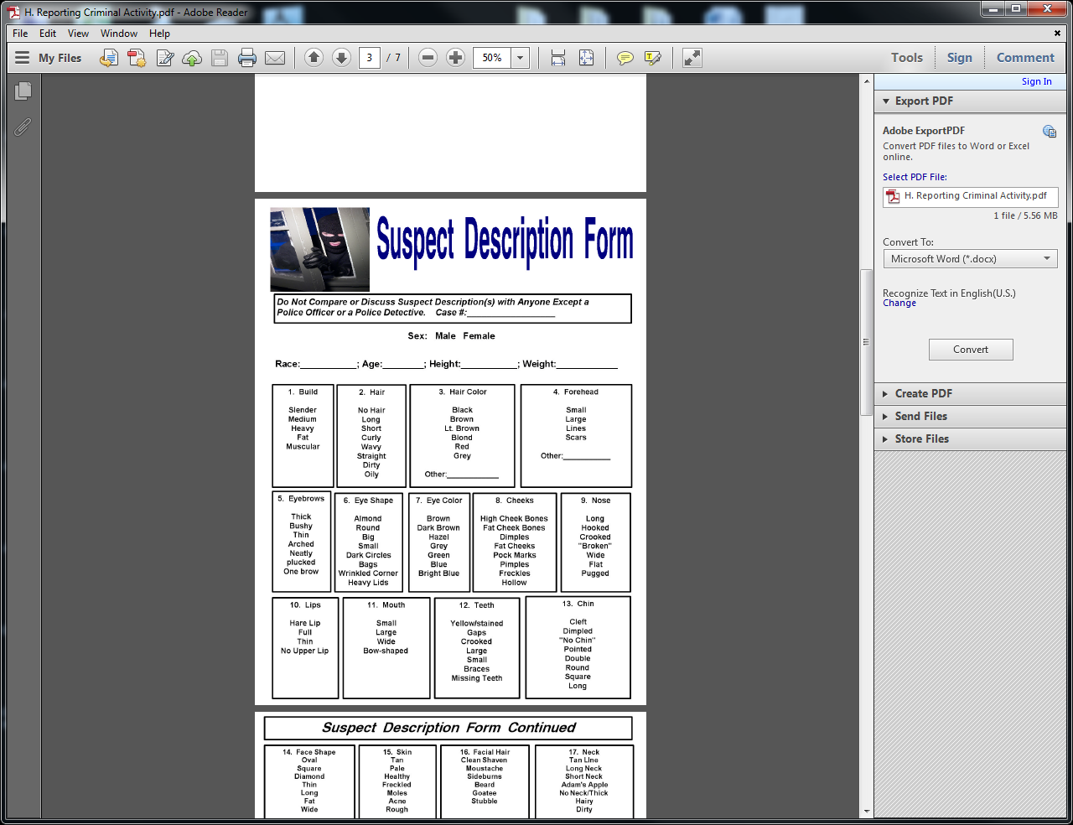
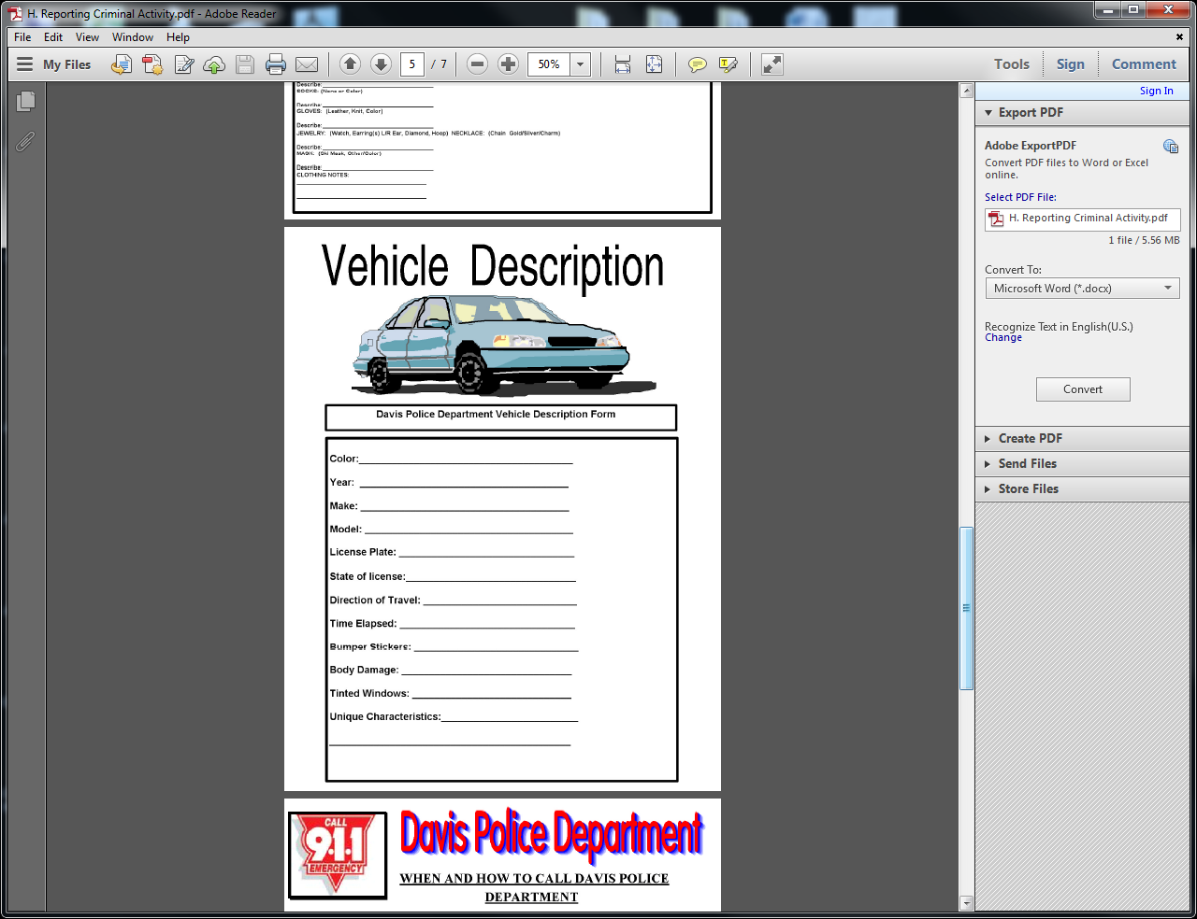
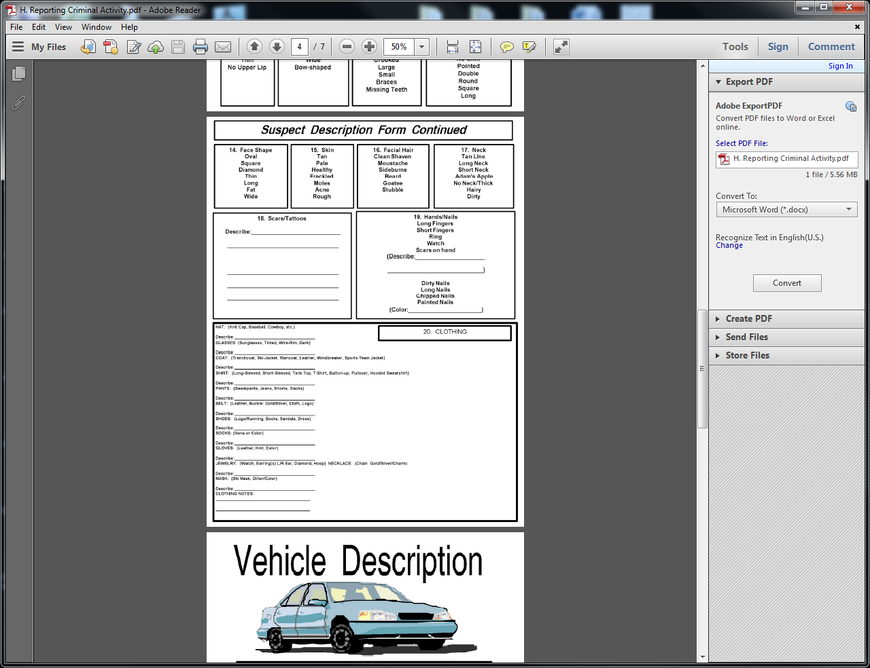

These forms have been included to help assist you in documenting complete and accurate descriptions in an emergency situation. Please take the time to review these pages and familiarize yourself with the information that is needed to provide a good description. Make copies for you and your neighbors to have available. An accurate description of a vehicle or person can be the difference between catching the culprit or allowing a criminal to escape arrest.

“Call immediately and use the forms to help provide accurate information or fill out the forms while the officers are enroute.”

DO NOT FILL OUT THE FORMS BEFORE CALLING THE POLICE AS TIME IS OF THE ESSENCE!

