**Summary for the Davis City Council**

**Air quality concerns with the Nishi site for air quality**. Thomas A. Cahill, Professor of Physics and Atmospheric Sciences (Emeritus), and Head, UC Davis DELTA Group, August 31, 2014

**Summary: Both near freeway measurements and the best air pollution models show that the Nishi property is subject to air pollution impacts that make any residential use of this property as currently envisioned inappropriate and a danger to the health of residents, especially children and the elderly.**

The problems can be divided by season:

**Summer**:

1. Normal afternoon Bay Breeze blows along I-80, “linear enhancement”, augmenting pollutant load. Pg. 2
2. The I-80 freeway is elevated upwind of Nishi, so pollutants will penetrate through the entire site. Pg. 3
   1. In a recent study we did in Sacramento, pollutants 1000 ft. downwind of an elevated section of I-5 were about the same as they were at the freeway edge.
3. There is often heavy upwind braking as I-80 necks down from 6 lanes to three, Pg. 5
   1. Causing ultra-fine metals that cause ischemic heart disease mortality, and
   2. Generating very fine iron that reduces the lung function of children.
4. There is then acceleration as the slowdown breaks up, with heavy emissions of diesels exhaust from the trucks, the most potent carcinogen in California air. Pg. 9
   1. There are validated ARB models that predict the cancer rate downwind of diesel sources.

**Winter** Pg. 9

1. Continued problems with braking and acceleration, ultra-fine metals, as in summer, but
2. Enhanced by stagnation prevents dispersion of I-80 and railroad pollutants.

**Mitigation:** Pg. 11

**The best decision is to avoid situations were mitigation is needed**. Many are unrealistic, none are completely effective. Model validations are also discussed.

Supporting information for these sections are in the Appendices.

* + 1. Letters to the Editor, Davis Enterprise Pg. 13
    2. HYSPLIT analyses Pg. 14

**Background:**

I have met once with the developer and once jointly with developer and city staff to express my concerns about this property. Note that I had worked with city staff and other developers on the New Harmony development, where the problems seen in Nishi in summer do not occur, and those in winter are much less and mitigated by changes in the development.

Letters to the Editor were published on both these topics (appended, Appendix A) The problems can be divided by season:

**Summer:**

1. **Normal afternoon Bay Breeze blows along I-80, “linear enhancement”, augmenting pollutant load.**

The prevailing summer daytime and evening winds blow into Davis along I-80, which allows pollutants to build up in the wind. Typical wind patterns are shown in Appendix B using the NOAA READY HYSPLIT trajectory model. This is enhanced by the I-80 and Hwy 113 intersection that involves slowing and braking and then acceleration, which enhance emissions.

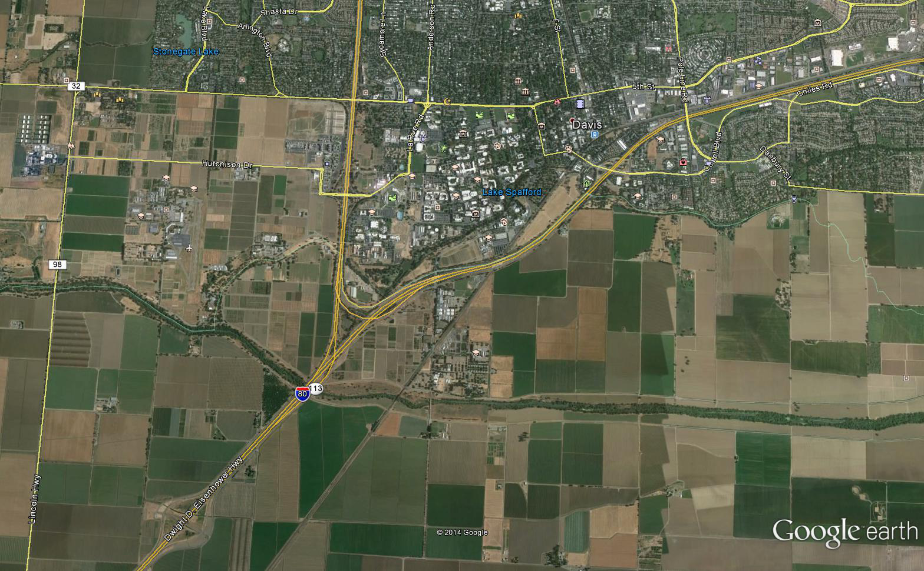

Prevailing summer winds

Figure 1 The Nishi property is at the end of the arrow.

Draxler, R.R. and Rolph, G.D. HYSPLIT (HYbrid Single-Particle Lagrangian Integrated Trajectory) Model access via NOAA ARL READY Website (http://www.arl.noaa.gov/HYSPLIT.php). NOAA Air Resources Laboratory, College Park, MD.

1. **I-80 freeway is elevated upwind, so pollutants penetrate through the entire site.**

As early as 1976, it was known that elevated freeways throw their pollutants farther downwind from the roadways than the standard models predict.

Feeney, P.J., T.A. Cahill, R.G. Flocchini, R.A. Eldred, D.J. Shadoan, and T. Dunn**. Effect of roadbed configuration on traffic derived aerosols.** *Journal of the Air Pollution Control Association.*  25:1145‑1147 (1975).

Below is a standard model Emfac2007, with the dispersion of pollutants from a flat, at-grade roadway. On it are both data from our 1976 lead study and Zhu’s 2002 study. All agree well, and there is little impact beyond 150 m (495 ft.).

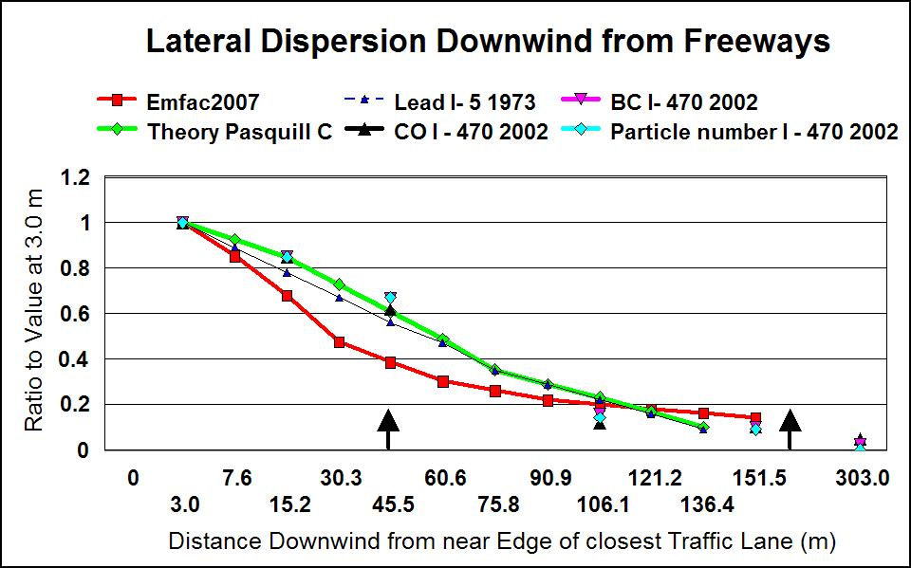

Figure 2. Downwind fall-off of pollutants for an at-grade roadway, including Zhu’s results 2002 and the 1973 lead data.

Zhu, Y., Hinds, W.C., Kim, S., Shen, S., Sioutas, C., **Study of ultra-fine particles near a major highway with heavy duty diesel traffic**,*Atmospheric Environment*.,36, 4323 – 4335 (2002)

But our 1976 study, and recent ones in Sacramento with Breathe California of Sacramento/Emigrant Trails show a very different pattern. After an original drop, the pollutants rise to about the same values they h**ad on the freeway even 1000 ft downwind.**

This helps explain the health effects seen in children living as far as 1 mile from freeways.

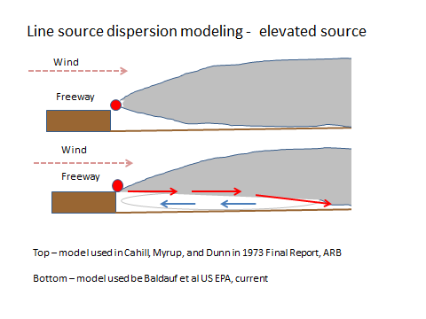

Figure 3 Conceptual model of raised section freeway meteorology (after Baldauf et al 2013)



Figure 4 Measurements downwind of I-5 at 35th Avenue, compared to both the standard model (green ) and our 1976 data (brown.) Extrapolation shown in dashed green to 1,000 ft.

Note that the distance from the top of the I-80, overcrossing to the southwest edge of the Nishi property in 250 m, (825 ft.) and to the farthest edge, 1200 m. (4000 ft.)

Thus, with the model’s extrapolation, we expect much of the Nishi property to have about the same level of pollutants as at the downwind edge of I-80 atop the overcrossing.

1. **There is often heavy braking as I-80 necks down from 6 lanes to three, causing ultra-fine metals which cause ischemic heart disease mortality.**

The situation is greatly degraded by the backups common as east bound I-80 necks down over the railroad over crossing until the freeway finally achieves its 3 lane configuration just before the Richards Boulevard overcrossing.

The reason that this is so important is that recent peer reviewed articles from our group and others have shown that the very fine and ultra-fine meals from brake wear are a major source of the observed ischemic heart disease death rate in the southern San Joaquin Valley. This was especially true for Bakersfield, which was impacted by metals from cars and trucking braking going down the I-5 Grapevine Grade and the Tehachapi pass.

**Very Fine and Ultra-Fine Metals and Ischemic Heart Disease in the California Central Valley 1: 2003 – 2007** Thomas A. Cahill, David E. Barnes, Nicholas J. Spada, Jonathan A. Lawton, and Thomas M. Cahill, **Aerosol Science and Technology 45, 1135-1142 (2011)**

**Abstract**

The enhancement of mortality associated with cardiovascular and specifically ischemic heart disease (IHD) has been observed in the California Central valley since at least 1990, and IHD continues to be the single largest source of mortality in much of the region. While there is a strong association of IHD with wintertime PM2.5 mass, potential causal agents identified in medical studies, such is very fine and ultra fine metals, have not been fully characterized in most Central Valley regions and not at all in the northern Sacramento Valley. To provide improved information on specific and potentially causal agents for future epidemiological studies, a five site aerosol sampling transect was conducted from Redding to Bakersfield during a 17 day period of strong stagnation January 5 to 22, 2009. Mass and elemental components were measured every 3 hours in 8 particle size modes, ranging from 10 μm to 0.09 μm, while the ultrafine particles (<0.09 μm) were collected on Teflon® filters. The ultrafine fraction can contain a significant proportion of the total transition metals and a very high number of insoluble ultra fine particles. The strongest association to current IHD mortality rates was found in very fine (0.26 to 0.09 µm) to ultrafine metals that were mostly derived from vehicular sources. The highest correlations between the IHD mortality rate, 2003 – 2007, for ultra fine Central Valley aerosols were for phosphorus (r2 = 0.96) and non-soil iron (r2 = 0.88), both with known vehicular sources..



Figure 5 Very fine transition metals with known vehicular sources, zinc and phosphorus from zinc thiophosphate in lubricating oil, iron and copper potentially from braking systems.



Bakersfield

Figure 6 Ischemic heart disease (IHD) in the California Central valley, 1989 -1991 versus 2003 – 2007. The 1989 – 1991 data are scaled to match the Shasta – Butte data, 2003 – 2007, since diagnostic protocols differed.

While most of the southern San Joaquin benefited from improvements when ultra-fine metals were reduced by improvements in oil extraction post 1990, Bakersfield continued to be impacted. There were entire hospitals that did only heart attacks there.

Thomas A. Cahill, David E. Barnes, Earl Withycombe, and Mitchell Watnik. **Very fine and ultra-fine metals and ischemic heart disease in the California Central Valley 2: 1974 – 1991.** *Aerosol Science and Technology* 45:1135-1142 (2011) doi:10.1080/02786826.2011.582196

The connection between car braking and accelerating and ultra-fine metals was recently published based on our Watt Avenue studies. Extensive studies were done at Arden Middle School directly downwind of Watt Avenue where a stop light causes braking and acceleration. In the paper, we clearly showed that the source was erosion of brake drums or pads and shoes, plus zinc from burned lubricating oils..

Cahill, Thomas A., , David E. Barnes, Nicholas J. Spada**, Seasonal variability of ultra-fine metals downwind of a heavily traveled secondary road,** Atmospheric Environment 94 173 - 179 (2014), 1The DELTA Group, University of California, Davis, CA, (530) 756 6126, [tacahill@ucdavis.edu](mailto:tacahill@ucdavis.edu), and 2 the Health Effects Task Force, Breathe California of Sacramento Emigrant Trails, Sacramento, CA

**Abstract**

Since 2002, we have been studying the impact of a heavily traveled secondary road on an adjacent downwind school located at a stop light controlled intersection. The prior studies were all performed in winter conditions with typically strong inversions, but established significant PM2.5  impacts on the school roughly in accord with theoretical models and the relevant literature. In this project, we have enhanced this effort by extending the study from winter to summer, and adding compositionally-resolved ultra-fine aerosol measurements. Ultra-fine aerosols, including metals derived from both brake wear and zinc in lubricating oil, were present at high concentrations in winter downwind of the roadway but absent at a residential site 500 m upwind. Their concentrations faded to minor levels in spring and early summer, while coarse roadway resuspended dust increased in that period.. A comparison of ultra-fine measurements in downtown Sacramento and other California Central Valley sites indicates that these traffic derived aerosols are widely present in urban areas impacted by heavy traffic, freeways and secondary streets, especially where heavy braking is occurring. The potential for health impacts of ultra-fine metals associated with cars braking and accelerating in inversion conditions is a serious health concern based on recent epidemiological studies.



Figure 7 Plot of selected elements from Table 3. In this plot, the winter and spring values were not averaged. Note that for this at-grade road, pollutants are reduced in spring, unlike at a raised section roadway where they transport horizontally far downwind..

Finally, there are extensive data on the loss of lung function in children living downwind of Los Angeles freeways. This can be ascribed to the presence of fine iron, FeO2, that generates free radicals in children’s lungs and destroys cells until scavenged by an anti-oxidant. This loss of lung capacity persists through life.

Gauderman, W. James, Edward Avol, Frank Gilliland, Hita Vora, Duncan Thomas, Kiros Berhane, Rob McConnell, Nino Kuenzli, Fred Lurmann, ., Edward Rappaport, Helene Margolis, David Bates, and John Peters, **The Effect of Air Pollution on Lung Development from 10 to 18 Years of Age***, N Engl J Med 2004*; 351:1057-1067[September 9, 2004](http://www.nejm.org/toc/nejm/351/11/) DOI: 10.1056/NEJMoa040610

All these effects have recently been summarized.

Health Effects Institute, **Traffic Related Air Pollution: A Critical Review of the Literature on Emissions, Exposure, and Health Effects**, HEI 17, Boston, MA (2009)

Thus, both meteorological and traffic models predict that there will be elevated levels of very fine and ultra-fine metals at the Nishi site, with potentially serious impacts on health via loss of lung function in children and ischemic heart disease mortality in adults. ,

1. **There is then acceleration as the slowdown breaks up, with heavy emissions of diesels exhaust from the trucks, the most potent carcinogen in California air**.

Diesel exhaust is the largest single component of the compounds that make up the CA Toxic Air Contaminates (TACs), contributing 70 % of the impact of all pollutants together.

In a recent study, we made specific measurements of carcinogens and compared then to the CA ARB’s models, with excellent agreement at the Roseville rail yard. We expect the effect to be less at Davis than Roseville, but as trains accelerate away from the David station going west there will be increased diesels pollutant emissions. In summer, most of the time, these will not impact the Nishi property. On the other hand, trucks heading east on I-80 will also accelerate after the bottleneck, and these will directly impact the Nishi site.

Thomas A. Cahill, Thomas M. Cahill, David E. Barnes, Nicholas J. Spada and Roger Miller. **Inorganic and organic aerosols downwind of California’s Roseville Railyard**. *Aerosol Science and Technology* 45:1049-1059 (2011) doi:10.1080/02786826.2011.580796



Figure 8 Association between local average annual daily (AADT) truck traffic on major freeways, scaled ischemic heart disease, and very fine plus ultra-fine iron. These data were all taken in winter inversion conditions

**Winter**

1. **Continued problems with braking and acceleration, ultra-fine metals, as in summer, but**
2. **Enhanced by stagnation prevents dispersion of I-80 and railroad pollutants**.

The situation in winter is exacerbated by the presence of strong surface based inversions. These trap pollutants close to the ground, and were a key factor in the death rate from ischemic heart disease in Bakersfield.

Below I show a plot from Cahill et al 2014 from the Watt Avenue study. Two effects are involved. First, there is a much smaller volume of air into which the pollutants can mix, holding them close to the ground. Second, wind velocities are low, so less mixing occurs with cleaner upwind air. In such conditions ultra-fine metals, very fine metals, and diesel exhaust will linger, pooling enhanced by the fraction of the raised freeway that makes a dead air pocket next to the base of the berm. This will be maximized on slow cold winds from the northeast, common in winter at night.



**Watt Avenue study**

Figure 8 PM2.5 mass data from the ARB downtown site at 13th and T Street and Del Paso Manor sites, Dec 10, 2006 to May 31, 2007. The period of the Watt Ave study is shown in the dotted line.

The effect of the inversion on fine mass is striking. Pollutants generated from sources stay near the sources and stay near the ground.

**Mitigation:**

**The best decision is to avoid situations were mitigation is needed**. None of the mitigations below are totally effective, and many are politically or economically unrealistic.

Potential mitigations include:

1. Source reductions:
2. Eliminating the back up as I-80 necks down to 3 lanes.
3. Removing iron, nickel, copper, and zinc from brake shoes and pads (a mitigation that I strongly encourage in any case),
4. Removing the stabilizer zinc thiophosphate from lubricating oils (a mitigation that I strongly encourage in any case),
5. Greatly reduced emissions from diesel trucks, (progress being made, but slow)
6. Greatly reduced diesel emissions from trains. , (progress being made, but very slowly, and threatened by additional rail traffic like oil trains)
7. Reductions from source to receptors.
8. Distance – not possible
9. Screening with trees. Helps especially for the finest pollutants, but quantification lacking – However, Not much room for vegetation. For an excellent existing screen see south of I-80 just east of Fairfield.

Baldauf, Richard, Greg McPherson, Linda Wheaton, Max Zhabg, Tom Cahill, Chad Bailey, Christina Hemphill-Fuller, Earl Withycombe, and Kori Titus, **Integrating Vegetation and Green Infrastructure into Sustainable Transportation Planning,** Transportation Research Bulletin, National Academy of Sciences (2013)

1. Sound walls – essentially useless
2. Mitigation at the receptors

1. Exterior mitigation - very difficult and not very effective.

Vegetation canopies – can reduce freeway very fine particles by a factor of three. Deciduous trees, the best in summer, are useless in winter.



Figure 10 Results of the 10th Ave “School transect” S and the 13th Ave Park Transect P (open bars).

Both had a Quality Assurance pair at site 2. Figure 8 (above ) shows the downwind pair P (Park) DW 2 A and B The ”Park Transect” had heavy canopy vegetation and decreased aerosol impact.

1. Interior mitigation

We have developed special filtration techniques for getting ultra-clean air in apartments. These were tested near the BNSF rail yard in San Bernardino and our presently working with the US Embassy staff in Beijing.

1. Model validation:

UC Davis DELTA Group has developed for the US EPA methods for measuring very fine and ultra-fine metals versus time, presently under contract to the US EPA NEXUS study, Detroit. Measurements of ultra-fine particles by number are not appropriate, as they do not separate harmless from harmful particles.

Clearly, I can not be associated with any future efforts from whatever the source.

**Appendix A**

Editor (published)

In the planning for the Nishi property, I strongly hold that no residences be built in the Nishi property, and that all businesses use advanced air cleaning equipment. We have published papers and are currently participating in a study on I-5 showing that being downwind of an elevated freeway projects dangerous pollutants much farther out than standard models like Emfac2007 predict. In addition, being downwind of any road, freeway or secondary street, that has heavy traffic of cars braking and accelerating, delivers a heavy load of very fine and ultra-fine metals. We have and others have published peer reviewed journal articles tying these metals to ischemic heart disease. Our references are posted on the UC Davis DELTA Group web site, [http://delta.ucdavis.ed](http://delta.ucdavis.edy)u, click on “recent publications”.

Tom Cahill

Editor (published)

Comment has been made about my recent letter giving my opinion that no residences be built in the Nishi property versus my prior support for the New Harmony project. I will post the full New Harmony analysis on the UCD DELTA web site <http://delta.ucdavis.edu> next week, but in summary my support of New Harmony was based on five main factors: 1) the dominant southwest winds almost always blow from New Harmony towards the freeway. The exceptions are strong northwest winds that have high dilution factors, which will be enhanced as the trees I requested grow taller. 2) The freeway is at-grade, unlike the elevated section upwind of Nishi, 3) The traffic north of New Harmony usually flows freely, with relatively little braking and acceleration (unlike just upwind of the Nishi property), 4) In 2002, I actually measured for 5 weeks, every 3 hr., pollution just south of I-80 about 1 ½ mile east of New Harmony as part of an American Lung Association (now Breathe California of Sacramento) valley transect. It was at about the same distance south of the freeway as New Harmony. On the average, the aerosols at that site were slightly less than at my house in Davis well west of Highway 113, 5) New Harmony has done clever things with air in takes, placing them farther from the freeway, and has excellent air filters.

Tom Cahill

**Appendix B HYSPLIT** analyses for 5 afternoon hours in July**.** Note: Times are Zulu (Greenwich mean)

